S-100 – Part 6

Coordinate Reference Systems
Summary of Substantive Changes in Edition 5.2.0

Change Summary | Clauses Effected
Part 6 – Coordinate Reference Systems

Contents

6-1 Scope 1
6-2 Normative References 1
6-3 Package Overview 2
6-3.1 The package diagram 2
6-4 Package details 3
6-4.1 The Identified Object package 3
6-4.1.1 S100_IO_IdentifiedObject 3
6-4.1.2 Class details 3
6-4.2 The Coordinate Reference Systems package 4
6-4.3 Single CRS 4
6-4.3.1 Compound CRS 5
6-4.3.2 Class details 5
6-4.4 The Coordinate System package 6
6-4.4.1 Class details 7
6-4.5 The Datum package 9
6-4.5.1 Class details 10
6-4.6 The Coordinate Operation package 11
6-4.6.1 Class details 13
Appendix 6-A – Examples (informative) 15

Page intentionally left blank

Scope
The S-100 standard has been designed for the producers and users of hydrographic information, however its principles can be extended to many other forms of geographic information including maps, and text documents.
The location of an object in the S-100 standard is defined by means of coordinates. Those coordinates relate a feature to a position. This Part describes all elements that are necessary to fully define the referencing by means of coordinate systems and datums. It defines the Conceptual Schema for the description of spatial referencing by coordinates and describes the minimum data required to define 1-, 2- and 3-dimensional spatial coordinate references.
In addition to the elements necessary to define a coordinate reference system this Part also describes operations to transform coordinates from one coordinate reference system to another. This includes operations for datum transformation and map projections.
Coordinate reference systems, as well as single elements to define them, may be registered in a register or defined by an organization in a document. This Part describes how those elements are identified.
A coordinate reference system shall not change with time within the scope of this Part.

Normative References
The following referenced documents are indispensable for the application of this document. For dated references, only the cited edition applies. For undated references, the latest edition of the referenced document (including any amendments) applies.
ISO 19111:2007, Geographic information — Spatial referencing by coordinates
ISO/TS 19103, Geographic information — Conceptual schema language
ISO 19115, Geographic information — Metadata

Package Overview

The package diagram
Figure 6.1 shows the packages used in this Part and their dependencies.
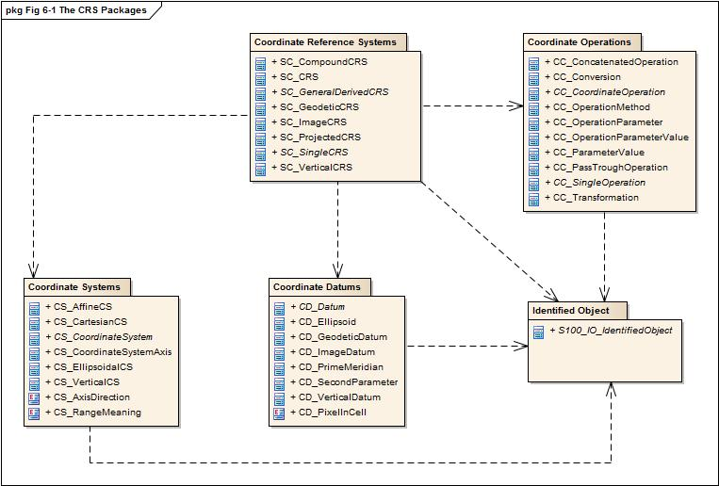
Figure 6-1 — The CRS packages
The elements for referencing spatial objects by use of coordinates are described in five packages. All packages depend on the package “Identified Objects”, which describes the mechanism of linking elements to external definitions.
It also assures that each element can be uniquely named to identify it in a data set or software application. To facilitate the work with class names, every package shall use a prefix for its classes and data types. Table 6-1 below shows the prefixes for various packages:
Table 6-1 — Package prefixes
Package name | Prefix
Identified Objects | IO
Coordinate Reference Systems | SC
Coordinate Systems | CS
Datums | CD
Coordinate Operations | CC

Package details

The Identified Object package
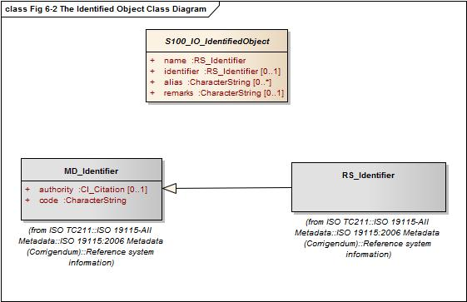
Figure 6-2 — The Identified Object class diagram
NOTE If a class diagram of a package shows classes or types of another package it will be shown with a grey background. In this case not all details of this class are shown; the full details are described in the class diagram of the package where the class belongs.

S100_IO_IdentifiedObject
Each class in this part is intended to have a mechanism to be identifiable and/or to identify an external source that is derived from the class S100_IO_IdentifiedObject.
Different from ISO 19111 this class is not derived from an external document but uses members defined by external standards. In addition, no other class in this part is derived from external standards. Where in ISO 19111 those classes inherit essential members, those members will be introduced here in the appropriate package diagram. This should improve the readability of this component and also avoids multiple inheritance where it is not absolutely needed.

Class details
Table 6-2 — Properties of the class IO_IdentifiedObject
Name | Type | Card. | Description
name | RS_Identifier | 1 | The primary name by which the object can be identified
identifier | RS_Identifier | 0..1 | An identifier that references the (external) definition of the object
alias | GenericName | 0..* | An alternative name of the object
remarks | CharacterString | 0..1 | Comments on or information about the object

The type RS_Identifier (from ISO 19115) has three parts:
- authority : CI_Citation [0..1];
- code : CharacterString;
- codeSpace: CharacterString [0..1]version: CharacterString [0..1].
The type CI_Citation is also defined in ISO 19115, for more details refer there.

The Coordinate Reference Systems package
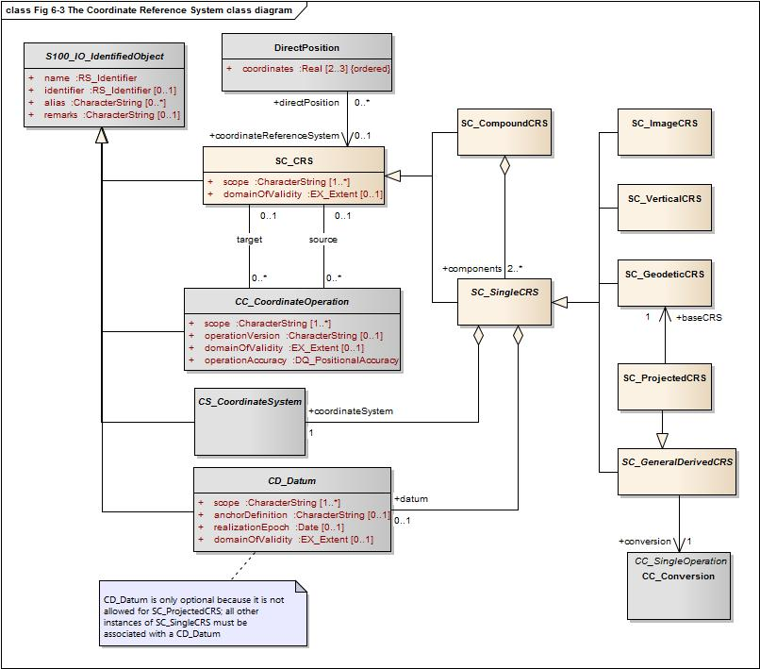
Figure 6-3 — The Coordinate Reference Systems class diagram
This package describes the base class used for all coordinate reference systems and all derived subclasses supported by this component. The diagram also shows the relation to classes in other packages.
A coordinate reference system is a coordinate system that is related to the real world by a datum. Generally, the real world will be the Earth although the principles are not restricted to the Earth. A coordinate reference system (CRS) is either a single CRS or a compound CRS.

Single CRS
A single CRS is defined by a coordinate system and an associated datum. The following types of single CRSs are supported by S-100:
- Geodetic CRS;
- Projected CRS;
- Vertical CRS;
- ImageCRS.

A geodetic CRS is associated with a geodetic datum. It usually uses an ellipsoidal coordinate system (geodetic latitude, geodetic longitude and ellipsoidal height if 3D). A geodetic CRS can also use a Cartesian coordinate system (3D, fixed to the earth). Coordinates referenced to a Cartesian system are rarely used in data sets but are used as intermediate coordinates during certain coordinate transformations.
A projected CRS is a derived CRS with a geodetic CRS as its base and using a map projection for coordinate conversion. The underlying coordinate system is always a Cartesian coordinate system. Projected CRS are frequently used for national coordinate systems.
A vertical CRS is a 1D CRS for reporting depth or heights and associated with a vertical datum. The ellipsoidal height cannot be captured with a vertical CRS. Ellipsoidal heights are an integral part of a 3D coordinate tuple of a geodetic CRS and cannot exist independently.
An image CRS is associated with an image datum that describes how the image coordinate system is related to the image. This relation is independent of whether or not the image is georeferenced. Georeferencing is performed through a transformation of the image CRS to a geodetic or a projected CRS.

Compound CRS
A compound CRS is a combination of two or more single CRSs although the use of more than two components is very unlikely. The components of a compound CRS must be independent. Two CRSs are independent if coordinates conforming to them cannot be changed from one CRS to the other by some coordinate operation. A horizontal and vertical CRS, for example, are independent while two vertical CRSs are not. Nesting of compound CRSs is not permitted, meaning all components must be single CRSs.
Each position in a data set, given with the class DirectPosition, must be bound to a CRS. If in a data set different vertical datums are used for each, a vertical coordinate system has to be defined. Those vertical coordinate systems can then be used as a component in a compound coordinate system to describe a three-dimensional coordinate.
If a data Product Specification allows a choice of geodetic datums, even if only one is allowed in a given dataset, transformation methods must be specified that enable the datasets to be used together in an application.

Class details
Table 6-3 — Properties of the class SC_CRS
Name | Type | Card. | Description
scope | CharacterString | 1..* | Description of usage, or limitations of usage, for which this CRS is valid
domainOfValidity | EX_Extend | 0..1 | Area or region in which this CRS is valid

Table 6-4 — Properties of the class SC_SingleCRS
Name | Type | Card. | Description
datum | CD_Datum | 0..1 | The datum with which the CRS is associated. The datum must be of an appropriate type (vertical or horizontal) for the CRS. Mandatory except for projected CRS, for which it must not be specified – the projected CRS uses the datum of its base CRS
coordinateSystem | CS_CoordinateSystem | 1 | Coordinate system used by the CRS

Table 6-5 — Properties of the class SC_GeneralDerivedCRS
Name | Type | Card. | Description
conversion | CC_Operation | 1 | The coordinate conversion method to convert the coordinates from the base to the derived CRS (for example a map projection)
Table 6-6 — Properties of the class SC_Projected CRS
Name | Type | Card. | Description
baseCRS | SC_GeodeticCRS | 1 | The geodetic CRS on which the CRS is based. In particular the datum of the base CRS is also used for the derived CRS

The Coordinate System package
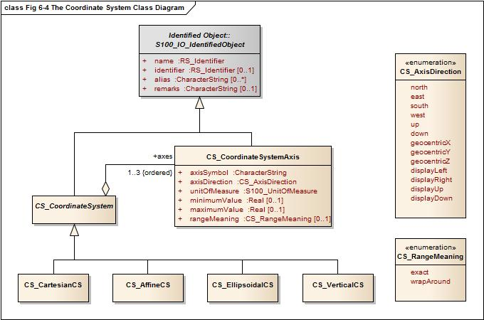
Figure 6-4 — The "Coordinate System" class diagram
A coordinate system comprises a non-repeating, ordered sequence of coordinate axes. The number of axes shall be equal to the number of dimensions of the space which geometry the CRS describes. The order of the coordinate axes is identical to the order of the coordinates in each coordinate tuple described by a CRS using this coordinate system.
This component defines four types of coordinate systems:
- Cartesian coordinate system;
- Affine coordinate system;
- Ellipsoidal coordinate system;
- Vertical coordinate system.
Each axis is defined by the direction, the value range and the unit of measure used.
A Cartesian coordinate system is a two- or three-dimensional coordinate system with orthogonal straight axes. All axes shall have the same length unit.
An affine coordinate system is a two- or three-dimensional coordinate system with straight axes that are not necessarily orthogonal. All axes shall have the same length unit.
An ellipsoidal coordinate system is a two- or three-dimensional coordinate system which describes coordinates on or nearby the surface of an ellipsoid. The coordinates are: geodetic latitude, geodetic longitude and (in the three-dimensional case) ellipsoidal height.

The geodetic latitude is the angle from the equatorial plane to the perpendicular to the ellipsoid through a given point, northwards treated as positive.
The geodetic longitude is the angle from the prime meridian plane to the meridian plane of a given point, eastward treated as positive.
The ellipsoidal height is the distance of a point from the ellipsoid measured along the perpendicular from the ellipsoid to this point, positive if upwards or outside of the ellipsoid.
A vertical coordinate system is a one-dimensional coordinate system used to record the heights or depths of points. Such a coordinate system is usually dependent on the Earth's gravity field. The following table specifies the type of CRS’s that can use the specific type of coordinate system.

Table 6-7 — Coordinate systems used for different CRS's
Coordinate Reference System | Coordinate System | Dimension
Geodetic CRS | Ellipsoidal coordinate system  Cartesian coordinate system | 2, 3  3
Projected CRS | Cartesian coordinate system | 2
Vertical CRS | Vertical coordinate system | 1
Image CRS | Cartesian coordinate system  Affine coordinate system | 2  2

Class details
Table 6-8 — Properties of the class CS_CoordinateSystem
Name | Type | Card. | Description
axes | CS_CoordinateSystemAxis | 1..3 | The axes of the coordinate system. The order is the same as the order of the coordinates in the corresponding positions. The number equals the dimension of the space for which the coordinate system describes the geometry

Table 6-9 — Properties of the class CS_CoordinateSystemAxis
Name | Type | Card. | Description
axisSymbol | CharacterString | 1 | Abbreviation used for this coordinate system axis.
axisDirection | CS_AxisDirection | 1 | Direction of the coordinate system axis. For an Earth-fixed coordinate system the value is often approximate and intended to provide a human interpretable meaning to the axis
minimumValue | double | 0..1 | The minimum value allowed for this axis in the axis’ units of measure
maximumValue | double | 0..1 | The maximum value allowed for this axis in the axis’ units of measure
rangeMeaning | CS_RangeMeaning | 0..1 | The meaning of the value range.
unit of measure | S100UnitOfMeasure | 1 | The unit of measure for this axis

Table 6-10— Definitions of the enumeration type CS_AxisOrentation
Name | Description
north | Axis positive direction is north. In a geodetic or projected CRS, north is defined through the geodetic datum
east | Axis positive direction is 90° (π/2 radians) clockwise from north
south | Axis positive direction is 180° (π radians) clockwise from north
west | Axis positive direction is 270° /3π/2 radians) clockwise from north
up | Axis positive direction is up relative to gravity
down | Axis positive direction is down relative to gravity
geocentricX | Axis positive direction is in the equatorial plane from the centre of the modelled earth towards the intersection of the equator with the prime meridian
geocentricY | Axis positive direction is in the equatorial plane from the centre of the modelled earth towards the intersection of the equator and the meridian π/2 radians eastwards from the prime meridian
geocentricZ | Axis positive direction is from the centre of the modelled earth parallel to its rotation axis and towards its north pole
displayLeft | Axis positive direction is left in display
displayRight | Axis positive direction is right in display
displayUp | Axis positive direction is up in display
displayDown | Axis positive direction is down in display

Table 6-11 — Definitions of the enumeration type CS_RangeMeaning
Name | Description
exact | Any value between and including minValue and maxValue is valid
wrapAround | The axis is continuous with values wrapping around at the minValue and maxValue. Values with the same meaning repeat modulo (maxValue – minValue). An example for this is the geodetic longitude; the axis is defined as a circle and the values wrap around ±π (±180°)

The Datum package
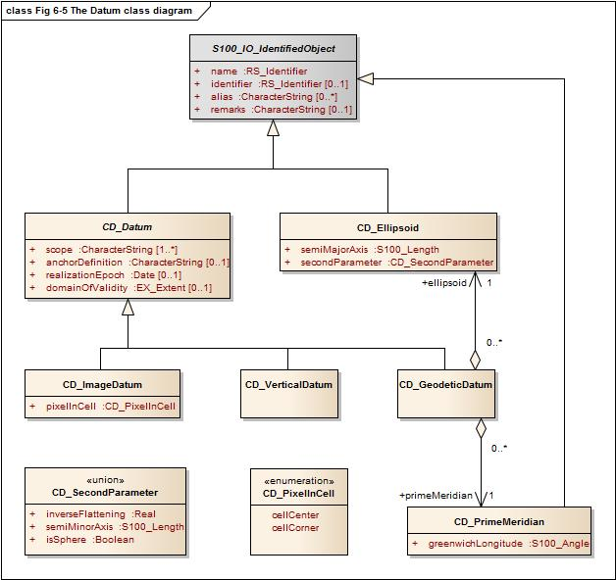
Figure 6-5 — The Datum class diagram
A datum is a parameter or set of parameters that defines the position of the origin, the scale, and the orientation of a coordinate system. Three types of datums are described by S-100:
- A geodetic datum;
- A vertical datum;
- An image datum.
A geodetic datum fixes the relationship of a two- or three-dimensional coordinate system to the Earth. This is done by means of an ellipsoid as the model of the Earth and of a prime meridian as the point of origin of geodetic longitude.
A vertical datum fixes the relationship between gravity-related heights or depths to the Earth. It is used to reference a vertical coordinate system. This relationship may be quite complex.
Ellipsoidal heights are treated as related to a three-dimensional ellipsoidal coordinate system referenced to a geodetic datum. They cannot be referenced by a vertical datum.
An image datum fixes the relationship between a coordinate system and an image. This is independent of whether the image is geo-referenced or not. An image CS is for locating a position within the image, not the position of the object in the real world
An ellipsoid in general is a quadratic surface given in Cartesian coordinates by:
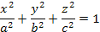
Where a, b, c are called semi-axes of the ellipsoid.
In the context of geodesy two semi-axes are equal (a=b) and a > c. This figure is also called an oblate spheroid. In S-100 the term ellipsoid is used for this special case and the two semi axes are denoted semi-major axis (a) and semi-minor axis (b), with a > b.
An ellipsoid can be defined either by its two semi-axes or alternatively by its semi-major axis and the inverse flattening:
If both semi-axes are equal the ellipsoid is a sphere. In this case the inverse flattening is not defined. (The flattening is 0).
To define the origin on the (circular) axis for the geodetic longitude the prime meridian is used. It is the meridian from which the longitudes of other meridians are quantified.

Class details
Table 6-12 — Properties of the class CD_Datum
Name | Type | Card. | Description
scope | CharacterString | 1..* | Description of usage, or limitations of usage, for which this datum is valid
anchorDefinition | CharacterString | 0..1 | A description, possibly including coordinates of an identified point or points, of the relationship used to anchor the coordinate system to the Earth or alternate object  For a geodetic datum this is known as the fundamental point  For an image datum it is usually a corner of the image or its centre
realizationEpoch | Date | 0..1 | The time after which this datum definition is valid
domainOfValidity | EX_Extent | 0..1 | Area or region in which this datum is valid

Table 6-13— Properties of the class CD_Ellipsoid
Name | Type | Card. | Description
semiMajorAxis | Length | 1 | The length of the semi-major axis of the ellipsoid
secondParameter | CD_SecondParameter | 1 | The second parameter to define the ellipsoid, either the length of the semi-minor axis or the inverse flattening of the ellipsoid

Table 6-14 — Properties of the union CD_SecondParameter
Name | Type | Card. | Description
inverseFlattening | double | 0..1 | the inverse flattening of the ellipsoid:
semiMinorAxis | Length | 0..1 | The length of the semi-minor axis of the ellipsoid
isSphere | boolean | 0..1 | true if the ellipsoid is a sphere

Table 6-15 — Properties of the class CD_PrimeMeridian
Name | Type | Card. | Description
greenwichLongitude | Angle | 1 | Longitude of the prime meridian measured from the Greenwich meridian, positive eastward
Table 6-16 — Properties of the class CD_GeodeticDatum
Name | Type | Card. | Description
Ellipsoid | CD_Ellipsoid | 1 | The ellipsoid used as a model of the Earth for this datum
primeMeridian | CD_PrimeMeridian | 1 | The prime meridian of this datum

Table 6-17 — Properties of the class CD_ImageDatum
Name | Type | Card. | Description
pixelInCell | CD_PixelInCell | 1 | Specification of the way the image grid is associated with the image data attributes

Table 6-18 — Definitions of the enumeration CD_PixelInCell
Name | Description
cellCenter | The origin of the image coordinate system is the centre of a grid cell or image pixel
cellCorner | The origin of the image coordinate system is the corner of a grid cell, or half-way between the centres of adjacent image pixels

The Coordinate Operation package
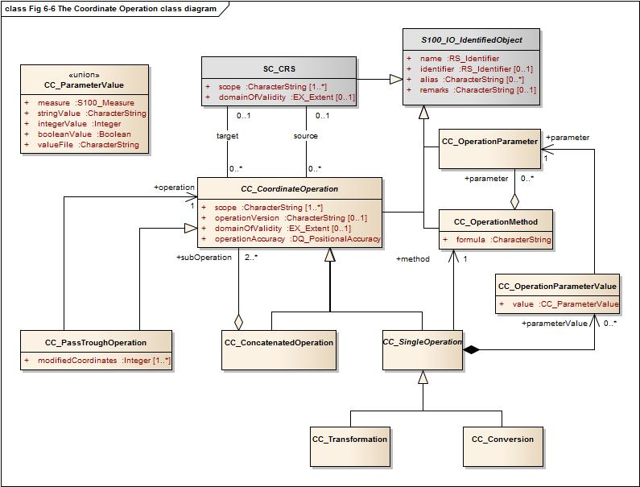
Figure 6-6 — The Coordinate Operation class diagram
Coordinate operations convert coordinates which refer to one coordinate reference system to coordinates that refer to another coordinate reference system. Therefore each coordinate operation has a source CRS and a target CRS.
The following types of coordinate operations are defined by S-100:
- Coordinate Transformation;
- Coordinate Conversion;
- Pass Through Operation;
- Concatenated Coordinate Operation.
A coordinate transformation changes coordinates from a coordinate reference system based on one datum to a coordinate reference system based on a second datum. The parameters of these operations are usually derived empirically. The stochastic nature of the parameters may result in several different versions of the same coordinate transformation. Therefore multiple coordinate transformations may exist for a given pair of coordinate reference systems, differing in their method, parameter values and accuracy characteristics.
A coordinate conversion changes coordinates between two coordinate reference systems based on the same datum. This type of coordinate operation includes map projections.
A pass through operation specifies what subset of a coordinate tuple is subject to a requested coordinate operation. It takes the form of referencing another coordinate operation and specifying a sequence of numbers defining the positions in the coordinate tuple of the coordinates affected by that coordinate operation.
EXAMPLE For a coordinate operation on the height coordinate of a tuple defined by a compound reference system the pass through operation filters the height coordinate prior to passing it to the relevant coordinate operation.
A concatenated coordinate operation is a non-repeating sequence of coordinate operations. This sequence of coordinate operations is constrained by the requirement that the target coordinate reference system of each step shall be the same as the source coordinate reference system of the next step. The source coordinate reference system of the first step and the target coordinate reference system of the last step are the source and target coordinate reference systems specified for the concatenated coordinate operation. Concatenated coordinate operation may contain coordinate conversions and coordinate transformations. If the datums of the source and target coordinate reference system are different the entire operation is a coordinate transformation.
An example of concatenation is the “Position vector 7-parameter transformation” (EPSG 9606), which is internally a concatenation of:
- A “Geographic/Geocentric conversion” (EPSG9602);
- A Helmert transformation on the geocentric coordinates; and
- The inverse case of the “Geographical/Geocentrical conversion”.
Although the first and the last step are conversions that are not changing the datum, the second step does, and therefore the entire operation is a transformation.
Coordinate transformation and conversions are single coordinate operations that use similar mathematical concepts. Those concepts (algorithms or procedures) are defined by an operation method. Each operation method is fully defined by a mathematical formula and a set of parameters, although this set may be empty.
The mathematical formulas for an operation are specified in text form or by referencing a source document.
Each instance of a single coordinate operation defines a value for each parameter of the corresponding operation method. Parameters and methods are identifiable objects and may be defined by referencing.

Class details
Table 6-19— Properties of the class CC_CoordinateOperation
Name | Type | Card. | Description
scope | CharacterString | 1..* | Description of usage, or limitations of usage, for which this coordinate operation is valid
operationVersion | CharacterString | 0..1 | Version of the coordinate transformation. Mandatory when describing a coordinate transformation, and should not be supplied for a coordinate conversion
domainOfValidity | EX_Extent | 0..1 | Area or region in which this coordinate operation is valid
operationAccuracy | DQ_PositionalAccuracy | 0..1 | Estimate of the impact of this coordinate operation on point accuracy

Table 6-20 — Properties of the class CC_SingleOperation
Name | Type | Card. | Description
method | CC_OperationMethod | 1 | The method (algorithm or procedure) used to perform the coordinate operation
parameterValue | CC_OperationParameterValue | 0..* | A value for each parameter of the associated method

Table 6-21 — Properties of the class CC_ConcatenatedOperation
Name | Type | Card. | Description
subOperation | CC_CoordinateOperation | 2..* | The ordered sequence of operations that are concatenated

Table 6-22 — Properties of the class CC_PassThroughOperation
Name | Type | Card. | Description
modifiedCoordinate | integer | 1..* | Ordered sequence of positive integers defining the positions in a coordinate tuple of the coordinates affected by this pass-through operation
operation | CC_CoordinateOperation | 1 | The coordinate operation for which this pass through operation specifies the subset of coordinates

Table 6-23 — Properties of the class CC_OperationMethod
Name | Type | Card. | Description
formula | CharacterString | 1 | Formula(s) or procedure used by this operation method
parameter | CC_OperationParameter | 0..* | A set of parameters used by this coordinate operation method

Table 6-24 — Properties of the class CC_OperationParameterValue
Name | Type | Card. | Description
value | CC_ParameterValue | 1 | Value of the coordinate operation parameter value. Most parameter values are numeric, but other types of parameter values are possible
parameter | CC_OperationParameter | 1 | Parameter for which the value is defined

Table 6-25 — Properties of the union CC_ParameterValue
Name | Type | Card. | Description
measure | S100_Measure | 0..1 | A numeric value of the coordinate operation parameter with its associated unit of measure
stringValue | CharacterString | 0..1 | A string value of the coordinate operation parameter
integerValue | integer | 0..1 | An integer value of the coordinate operation parameter. Usually used for a count or index
booleanValue | boolean | 0..1 | A Boolean value of the coordinate operation parameter
valueFile | CharacterString | 0..1 | Reference to a file containing one or more parameter values. This can be a filename or an URL or some other method to reference a file

Appendix 6-A
Examples
(informative)
Four examples are shown in this Appendix to demonstrate the use of the required information to describe a coordinate reference system:
- 2D geodetic CRS using references to an external source;
- Projected CRS using references to an external source;
- The same CRS defining all details in place;
- A compound CRS combining the first example with a vertical CRS.
An XML like notation is used for the examples. UML identifiers are used as element names. Values are shown in bold. For a better overview, data types may be included in the element’s name and shown in blue.

  - 2D geodetic CRS using references to an external source
This example uses a reference to the EPSG Geodetic Parameter Data Set. Please note that the class SC_CRS is used for the referencing and all details are defined in the referenced source. An exception is the scope since this is a mandatory field in the class SC_CRS.
<SC_CRS:example1>
<RS_Identifier:name>
<code>WGS 84</code>
</RS_Identifier:name>
<RS_Identifier:identifier>
<CI_Citation:authority>
<title>EPSG Geodetic Parameter Data Set</title>
<edition>6.5</edition>
<CI_Date:date>
<date>20040113</date>
<dateType>revision</dateType>
</CI_Date:date>
</CI_Citation:authority>
<code>4326</code>
</RS_Identifier:identifier>
<scope>
Horizontal component of the 3D geodetic CRS used by the GPS satellite system.
</scope>
</SC_CRS:example1>

  - Projected CRS using references to an external source
This example is similar to 6-A-1. It defines a projected CRS by referencing the EPSG Geodetic Parameter Data Set.
<SC_CRS:example2>
<RS_Identifier:name>
<code>Amersfoort / RD new</code>
</RS_Identifier:name>
<RS_Identifier:identifier>
<CI_Citation:authority>
<title>EPSG Geodetic Parameter Data Set</title>
<edition>6.5</edition>
<CI_Date:date>
<date>20040113</date>
<dateType>revision</dateType>
</CI_Date:date>
</CI_Citation:authority>
<code>28992</code>
</RS_Identifier:identifier>
<scope>
Large and medium scale topographic mapping and engineering survey.
</scope>
</SC_CRS:example2>

  - Projected CRS defining all details
This example is the full detail of 6-A-2.
<SC_ProjectedCRS:example3>
<!-- name and scope -->
<RS_Identifier:name>
<code>Amersfoort / RD new</code>
</RS_Identifier:name>
<scope>
Large and medium scale topographic mapping and engineering survey.
</scope>

<!-- the coordinate system -->
<CS_CartesianCS:coordinateSystem>
<!-- axis # 1 -->
<CS_CoordinateSystemAxis:axis>
<RS_Identifier:name>
<code>Easting</code>
</RS_Identifier:name>
<axisSymbol>X</axisSymbol>
<axisDirection>east</axisDirection>
<CS_UnitOfMeasure:unitOfMeasure>
<RS_Identifier:name>
<code>Metre</code>
</RS_Identifier:name>
<symbol>m</symbol>
<type>length</type>
</CS_UnitOfMeasure:unitOfMeasure>
</CS_CoordinateSystemAxis:axis>
<!-- axis # 2 -->
<CS_CoordinateSystemAxis:axis>
<RS_Identifier:name>
<code>Northing</code>
</RS_Identifier:name>
<axisSymbol>Y</axisSymbol>
<axisDirection>north</axisDirection>
<CS_UnitOfMeasure:unitOfMeasure>
<RS_Identifier:name>
<code>Metre</code>
</RS_Identifier:name>
<symbol>m</symbol>
<type>length</type>
</CS_UnitOfMeasure:unitOfMeasure>
</CS_CoordinateSystemAxis:axis>
</CS_CartesianCS:coordinateSystem>
<!-- end of the coordinate system -->

<!-- the coordinate conversion -->
<CC_Conversion:conversion>
<RS_Identifier:name>
<code>RD New</code>
</RS_Identifier:name>
<scope>
Large and medium scale topographic mapping and engineering survey.
</scope>
<!-- the operation method including the list of parameters -->
<CC_OperationMethod:method>
<RS_Identifier:name>
<code>Oblique Stereographic</code>
</RS_Identifier:name>
<formula>See EPSG guidance No. 7</formula>
<CC_OperationParameter:parameter>
<RS_Identifier:name>
<code>Latitude of natural origin</code>
</RS_Identifier:name>
</CC_OperationParameter:parameter>
<CC_OperationParameter:parameter>
<RS_Identifier:name>
<code>Longitude of natural origin</code>
</RS_Identifier:name>
</CC_OperationParameter:parameter>
<CC_OperationParameter:parameter>
<RS_Identifier:name>
<code>Scale factor at natural origin</code>
</RS_Identifier:name>
</CC_OperationParameter:parameter>
<CC_OperationParameter:parameter>
<RS_Identifier:name>
<code>False easting</code>
</RS_Identifier:name>
</CC_OperationParameter:parameter>
<CC_OperationParameter:parameter>
<RS_Identifier:name>
<code>False northing</code>
</RS_Identifier:name>
</CC_OperationParameter:parameter>
</CC_OperationMethod:method>
<!-- The parameter value # 1 -->
<CC_OperationParameterValue:parameterValue>
<parameter>Latitude of natural origin</parameter>
<CC_ParameterValue:value>
<CC_Measure:measure>
<value>52° 9’ 22.1780” N</value>
<CS_UnitOfMeasure:uom>
<RS_Identifier:name>
<code>Degree</code>
</RS_Identifier:name>
<type>angle</type>
</CS_UnitOfMeasure:uom>
</CC_Measure:measure>
</CC_ParameterValue:value>
</CC_OperationParameterValue:parameterValue>
<!-- The parameter value # 2 -->
<CC_OperationParameterValue:parameterValue>
<parameter>Longitude of natural origin</parameter>
<CC_ParameterValue:value>
<CC_Measure:measure>
<value>5° 23’ 15.5” E</value>
<CS_UnitOfMeasure:uom>
<RS_Identifier:name>
<code>Degree</code>
</RS_Identifier:name>
<type>angle</type>
</CS_UnitOfMeasure:uom>
</CC_Measure:measure>
</CC_ParameterValue:value>
</CC_OperationParameterValue:parameterValue>
<!-- The parameter value # 3 -->
<CC_OperationParameterValue:parameterValue>
<parameter>Scale factor at natural origin</parameter>
<CC_ParameterValue:value>
<CC_Measure:measure>
<value>0.9999079</value>
<CS_UnitOfMeasure:uom>
<RS_Identifier:name>
<code>Scale</code>
</RS_Identifier:name>
<type>scale</type>
</CS_UnitOfMeasure:uom>
</CC_Measure:measure>
</CC_ParameterValue:value>
</CC_OperationParameterValue:parameterValue>
<!-- The parameter value # 4 -->
<CC_OperationParameterValue:parameterValue>
<parameter>False easting</parameter>
<CC_ParameterValue:value>
<CC_Measure:measure>
<value>155000</value>
<CS_UnitOfMeasure:uom>
<RS_Identifier:name>
<code>Metre</code>
</RS_Identifier:name>
<symbol>m</symbol>
<type>length</type>
</CS_UnitOfMeasure:uom>
</CC_Measure:measure>
</CC_ParameterValue:value>
</CC_OperationParameterValue:parameterValue>
<!-- The parameter value # 5 -->
<CC_OperationParameterValue:parameterValue>
<parameter>False northing</parameter>
<CC_ParameterValue:value>
<CC_Measure:measure>
<value>463000</value>
<CS_UnitOfMeasure:uom>
<RS_Identifier:name>
<code>Metre</code>
</RS_Identifier:name>
<symbol>m</symbol>
<type>length</type>
</CS_UnitOfMeasure:uom>
</CC_Measure:measure>
</CC_ParameterValue:value>
</CC_OperationParameterValue:parameterValue>
</CC_Conversion:conversion>
<!-- end of coordinate conversion -->

<!-- the base geodetic CRS -->
<SC_GeodeticCRS:baseCRS>
<!-- the coordinate system of the base CRS-->
<CS_GeodeticCS:coordinateSystem>
<!-- axis # 1 -->
<CS_CoordinateSystemAxis:axis>
<RS_Identifier:name>
<code>Latitude</code>
</RS_Identifier:name>
<axisSymbol>φ</axisSymbol>
<axisDirection>north</axisDirection>
<CS_UnitOfMeasure:unitOfMeasure>
<RS_Identifier:name>
<code>Degree</code>
</RS_Identifier:name>
<symbol>°</symbol>
<type>angle</type>
</CS_UnitOfMeasure:unitOfMeasure>
</CS_CoordinateSystemAxis:axis>
<!-- axis # 2 -->
<CS_CoordinateSystemAxis:axis>
<RS_Identifier:name>
<code>Longitude</code>
</RS_Identifier:name>
<axisSymbol>λ</axisSymbol>
<axisDirection>east</axisDirection>
<CS_UnitOfMeasure:unitOfMeasure>
<RS_Identifier:name>
<code>Degree</code>
</RS_Identifier:name>
<symbol>°</symbol>
<type>angle</type>
</CS_UnitOfMeasure:unitOfMeasure>
</CS_CoordinateSystemAxis:axis>
</CS_GeodeticCS:coordinateSystem>
<!-- end of coordinate system of the base CRS -->

<!-- the geodetic datum -->
<CD_GeodeticDatum:datum>
<RS_Identifier:name>
<code>Amersfoort</code>
</RS_Identifier:name>
<scope>
Geodetic survey, cadastre, topographic mapping, engineering survey.
</scope>
<CD_Ellipsoid:ellipsoid>
<RS_Identifier:name>
<code>Bessel 1841</code>
</RS_Identifier:name>
<semiMajorAxis>6377397.155 m</semiMajorAxis>
<CD_SecondParameter:secondParameter>
<inversFlattening>299.1528128</inversFlattening>
<CD_SecondParameter:secondParameter>
</CD_Ellipsoid:ellipsoid>
<CD_PrimeMeridian:primeMeridian>
<RS_Identifier:name>
<code>Greenwich</code>
</RS_Identifier:name>
<greenwichLongitude>0</greenwichLongitude>
<CD_PrimeMeridian:primeMeridian>
</CD_GeodeticDatum:datum>
<!-- end of the geodetic datum -->
</SC_GeodeticCRS:baseCRS>
<!-- end of base geodetic CRS -->
</SC_ProjectedCRS:example3>

  - A compound CRS combining the first example with a vertical CRS
Here a compound CRS is defined. The horizontal component will be defined by referencing the vertical component and is defined by details (again only the vertical datum is again defined by referencing).
<SC_CompoundCRS:example4>
<!-- The horizontal component -->
<SC_CRS:component>
<RS_Identifier:name>
<code>WGS 84</code>
</RS_Identifier:name>
<RS_Identifier:identifier>
<CI_Citation:authority>
<title>EPSG Geodetic Parameter Data Set</title>
<edition>6.5</edition>
<CI_Date:date>
<date>20040113</date>
<dateType>revision</dateType>
</CI_Date:date>
</CI_Citation:authority>
<code>4326</code>
</RS_Identifier:identifier>
<scope>
Horizontal component of the 3D geodetic CRS used by the GPS satellite system.
</scope>
</SC_CRS:component>
<!-- The vertical component -->
<SC_VerticalCRS:component>
<RS_Identifier:name>
<code>Mean low water springs</code>
</RS_Identifier:name>
<scope>Hydrography</scope>
<CS_VerticalCS:coordinateSystem>
<RS_Identifier:name>
<code>Gravity related depth</code>
</RS_Identifier:name>
<!-- axis # 1 -->
<CS_CoordinateSystemAxis:axis>
<RS_Identifier:name>
<code>Depth</code>
</RS_Identifier:name>
<axisSymbol>z</axisSymbol>
<axisDirection>down</axisDirection>
<CS_UnitOfMeasure:unitOfMeasure>
<RS_Identifier:name>
<code>Metre</code>
</RS_Identifier:name>
<symbol>m</symbol>
<type>length</type>
</CS_UnitOfMeasure:unitOfMeasure>
</CS_CoordinateSystemAxis:axis>
<!-- The vertical datum (referenced to S-57 Attribute Catalogue) -->
<CD_VerticalDatum:datum>
<RS_Identifier:name>
<code>Mean low water springs</code>
</RS_Identifier:name>
<RS_Identifier:identifier>
<CI_Citation:authority>
<title>
IHO TRANSFER STANDARD for DIGITAL HYDROGRAPHIC DATA - Annex A
</title>
<edition>3.1</edition>
<CI_Date:date>
<date>200011</date>
<dateType>publication</dateType>
</CI_Date:date>
</CI_Citation:authority>
<code>VERDAT 1</code>
</RS_Identifier:identifier>
<scope>Hydrography</scope>
</CD_VerticalDatum:datum>
</CS_VerticalCS:coordinateSystem>
</SCVerticalCRS:component>
</SC_CompoundCRS:example4>

Page intentionally left blank

Exactly one member must be defined
Exactly one member must be defined

